

Programme Name: ________**BCS HONS**_______________________________________

Course Code: __**STAT 1000**________

Course Name: ________**Introduction to Statistics**______________________________

_**First Assignment**___

Date of Submission: ______**4/18/2021**_____________

**Submitted By: Submitted To:**

Student Name**: Dipesh Tha Shrestha** Faculty Name**: Shanta Rayamajhi Basnet**

IUKL ID: **041902900028** Department**: LMS**

Semester**: Third Semester**

Intake**: September 2019**

1. Define statistics. What are the uses of statistics in ICT give suitable examples

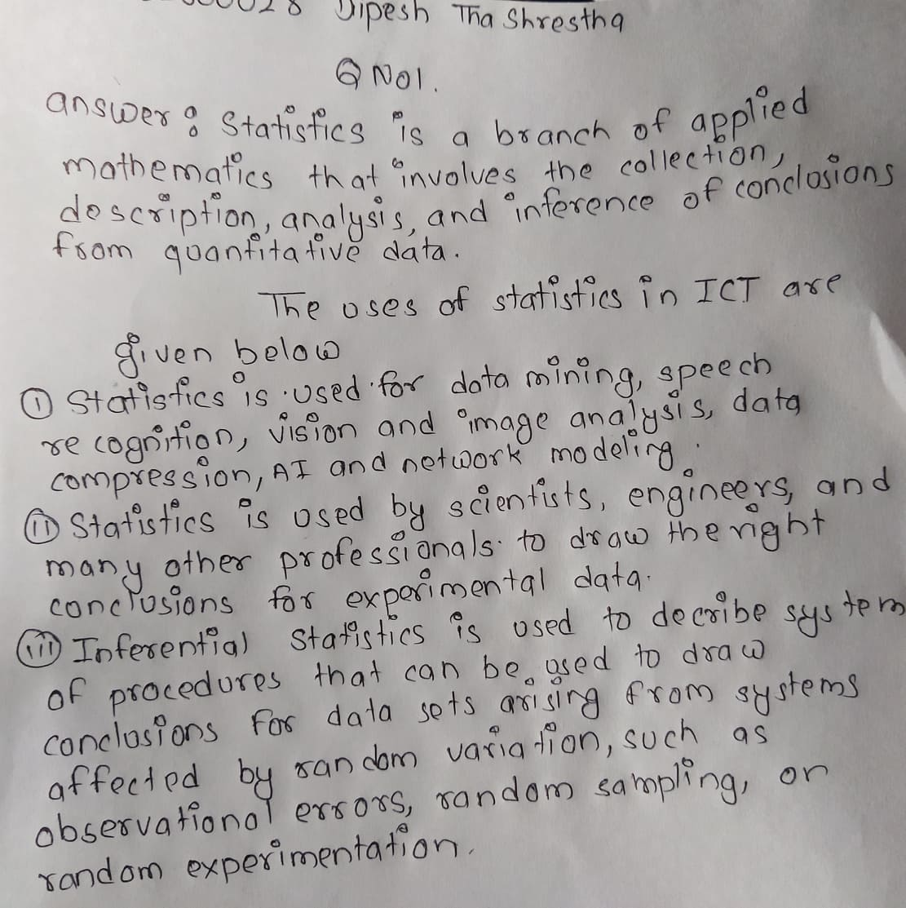

1. In a deck of 52 cards, a card is drawn at random. What is the probability that the card is black or king?

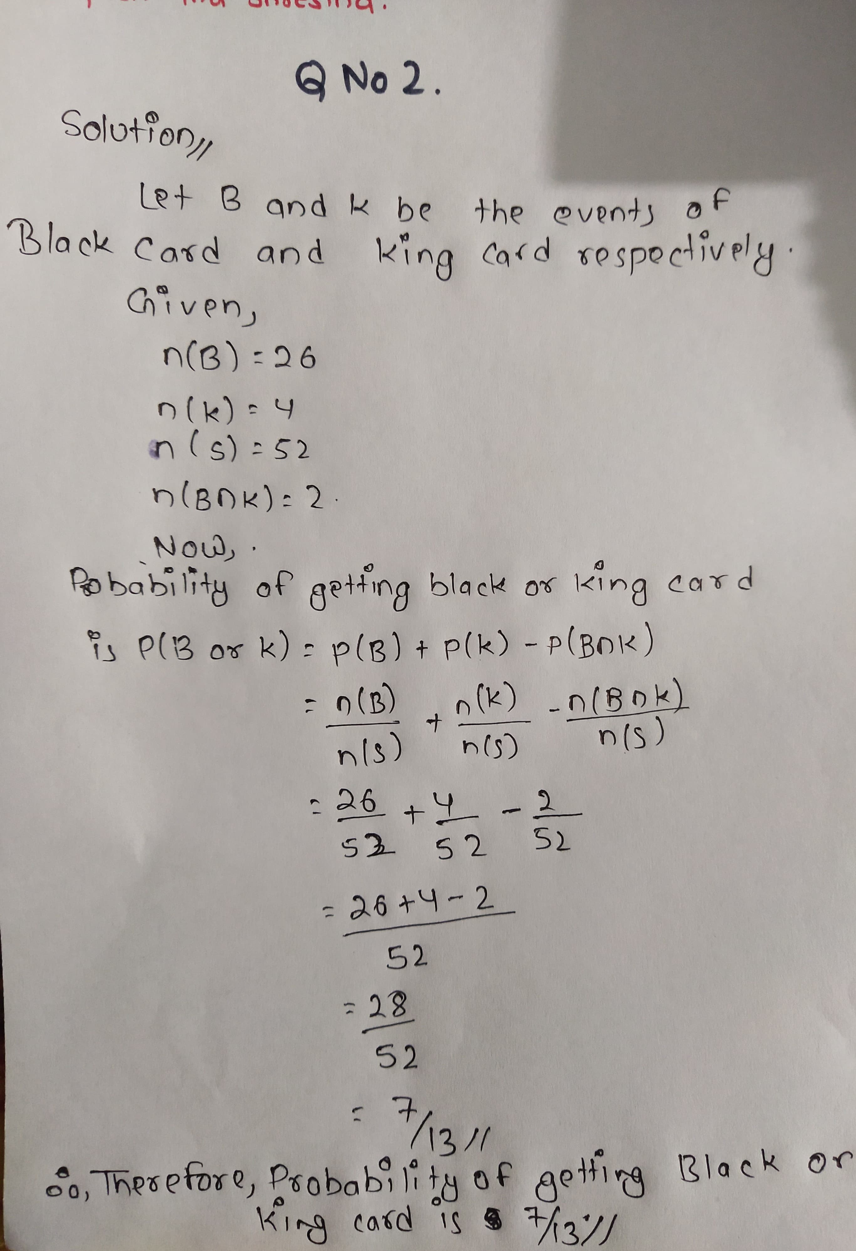

**Q.N. 3**

Following are the marks secured by Mr.A and Mr.B in 10 tests of 50 marks each

|  |  |  |  |  |  |  |  |  |  |  |
| --- | --- | --- | --- | --- | --- | --- | --- | --- | --- | --- |
| Test | 1 | 2 | 3 | 4 | 5 | 6 | 7 | 8 | 9 | 10 |
| Marks Secured by A | 24 | 37 | 27 | 30 | 31 | 34 | 36 | 26 | 29 | 33 |
| Marks Secured by B | 22 | 40 | 35 | 24 | 26 | 36 | 34 | 28 | 30 | 27 |

1. If the consistency of performance is the criteria for awarding a prize. Who should be awarded by the prize?
2. Who is better?
3. Who is more intelligent?

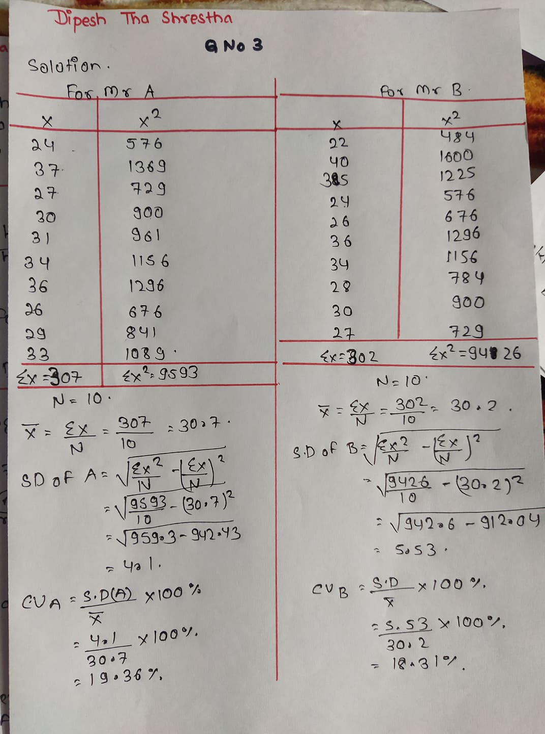 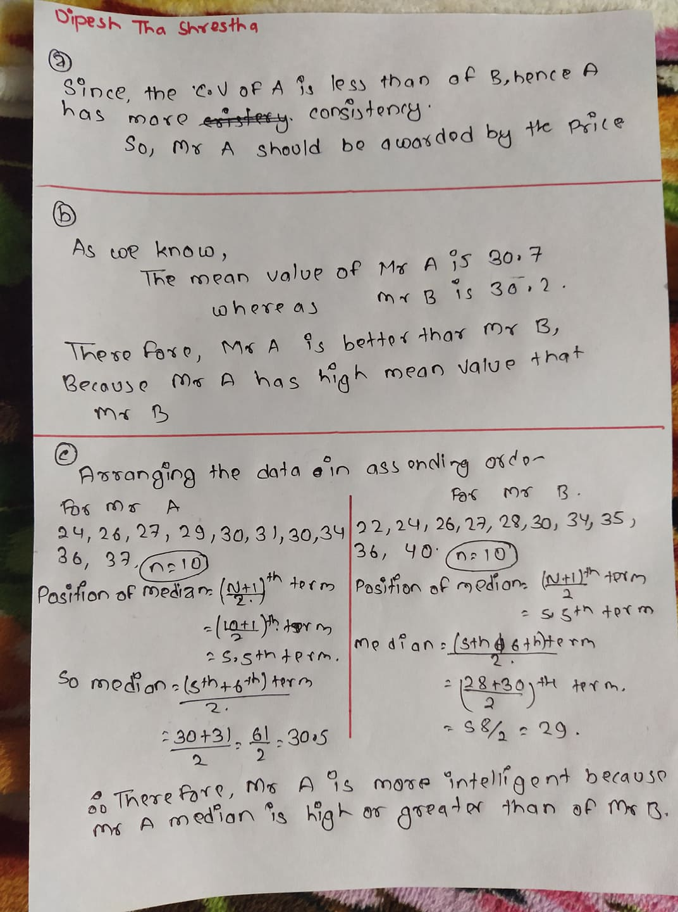

**Q.N. 4**

The following table shows the survey results regarding the purchase behavior of HDTV’s and DVD players in the last six months of 300 house hold.

|  |  |  |  |
| --- | --- | --- | --- |
| **Purchased Force TV** | **Purchase DVD** | |  |
|  | Yes | No | Total |
| Force TV | 38 | 42 | 80 |
| Not Force TV | 70 | 150 | 220 |
| Total | 108 | 192 | 300 |

1. What is the probability that purchased a TV set which is Force TV?
2. Find the probability that a randomly selected household that purchased a force TV and DVD player?
3. What is the probability that they purchased Force TV or DVD players?
4. What is the probability that a house hold purchased a DVD player when it is given that household purchased Force TV?

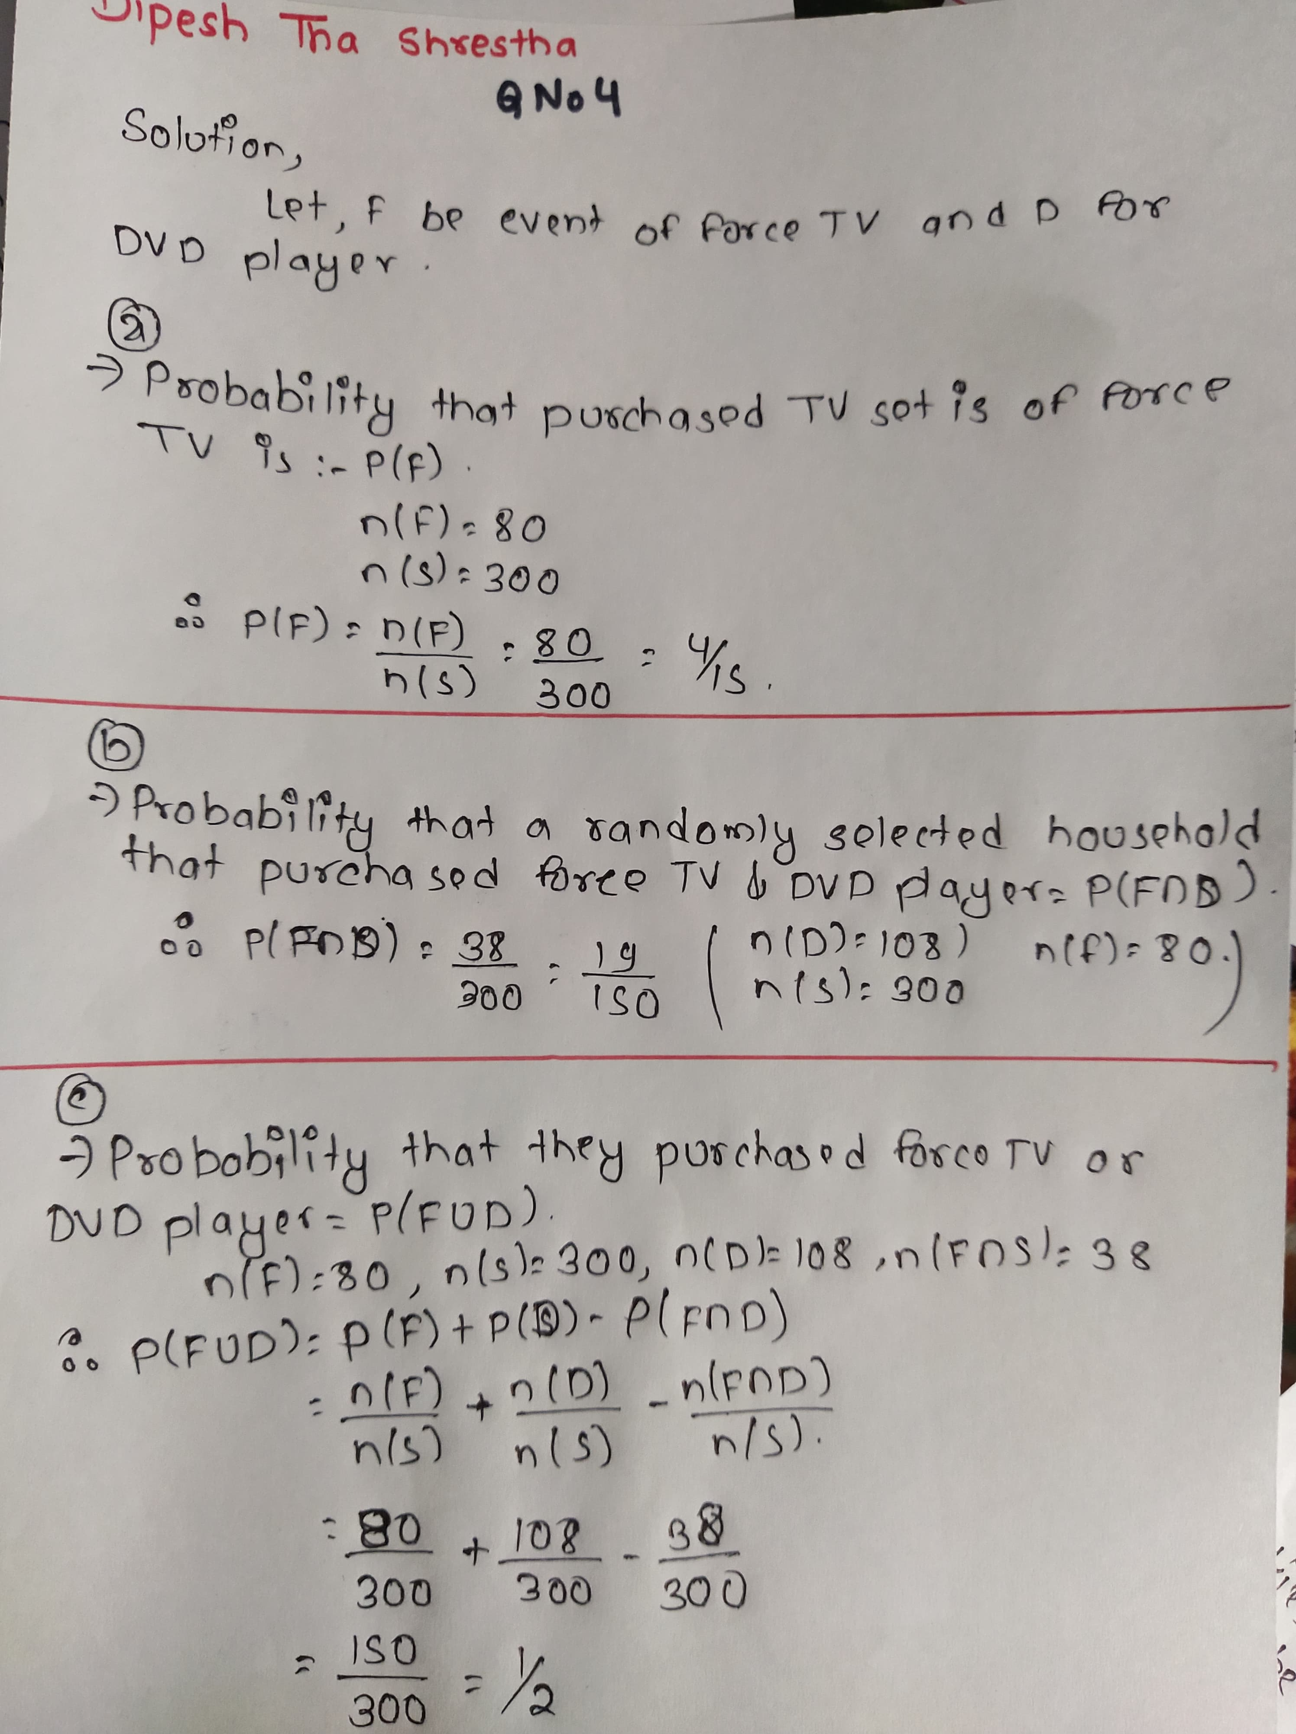 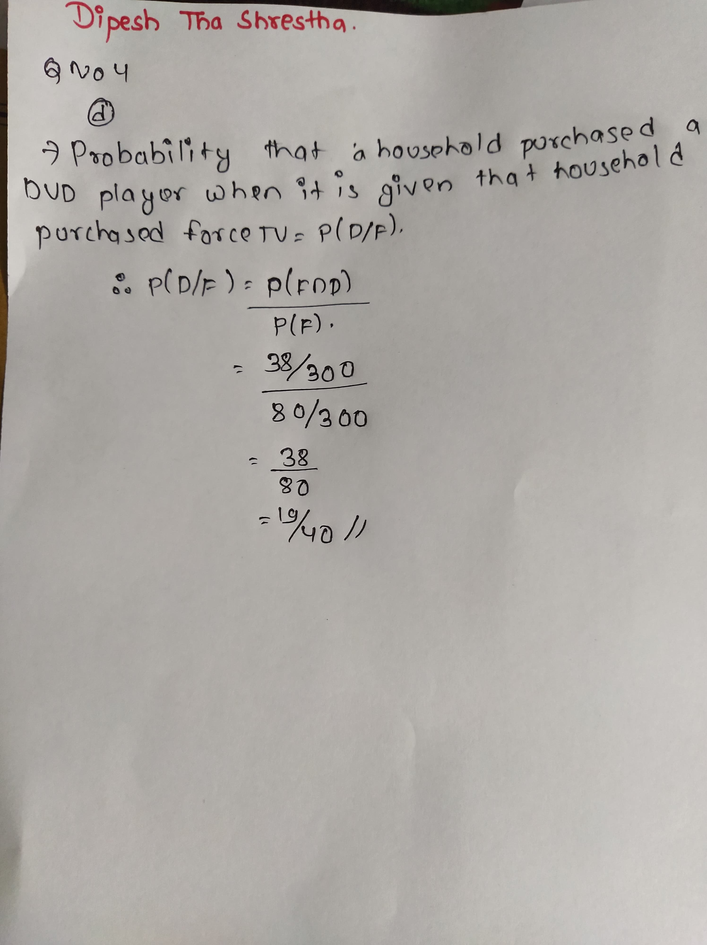

Q.N.5

According to the data from American Medical Association 15 %of US are left handed.

1. If 4 people are randomly selected
2. What is the probability that they are all left- handed?
3. What is the probability that at least one of them is left handed?
4. If groups of 50 people are randomly selected
5. What is the mean number of left-handed people in such group?
6. What is the standard deviation for the numbers of left handed people in such groups?

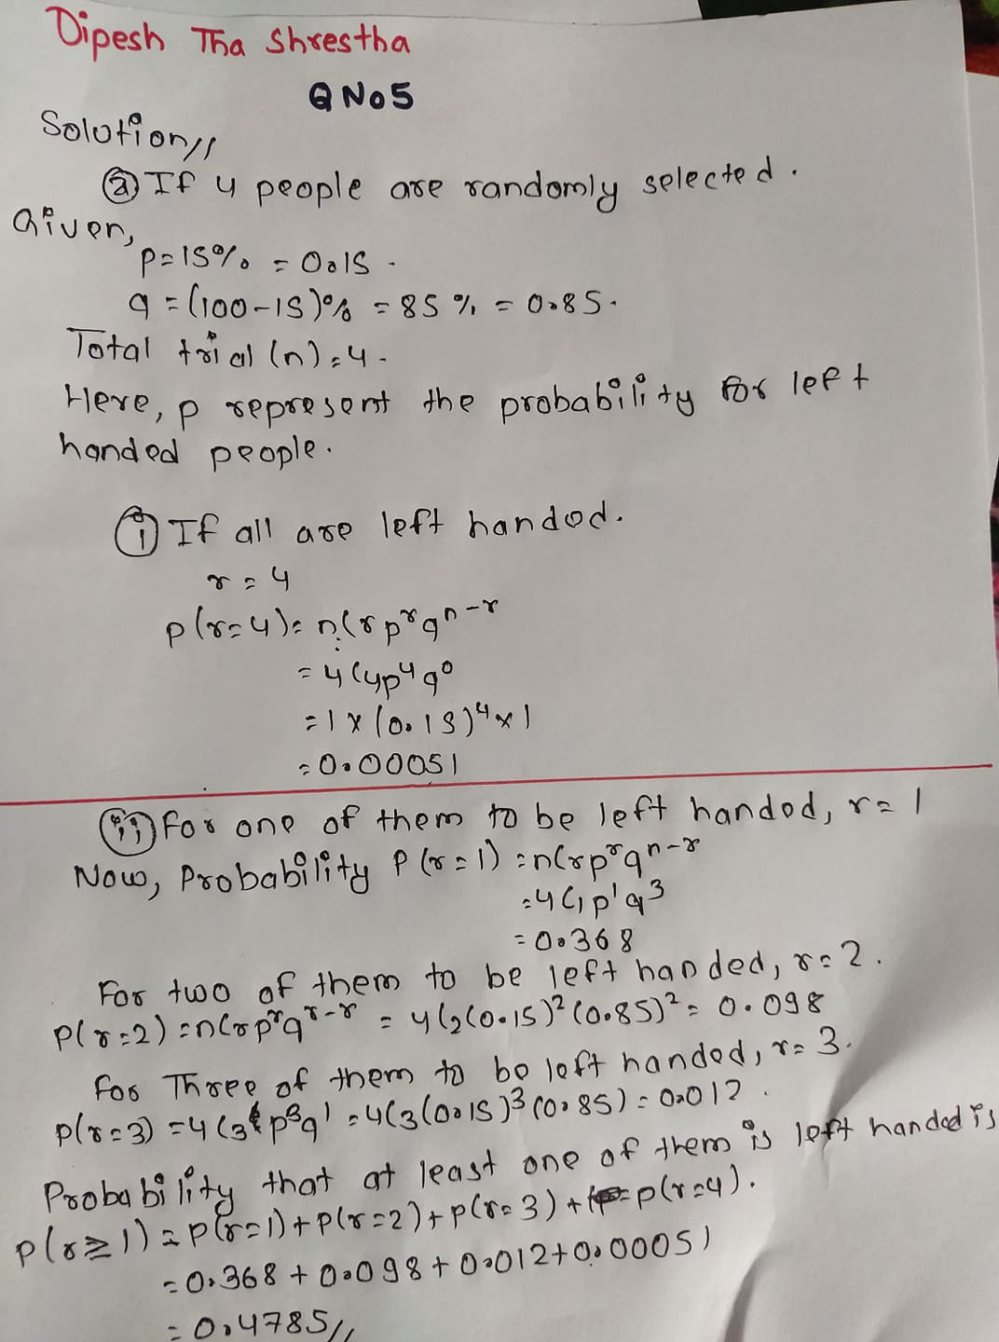

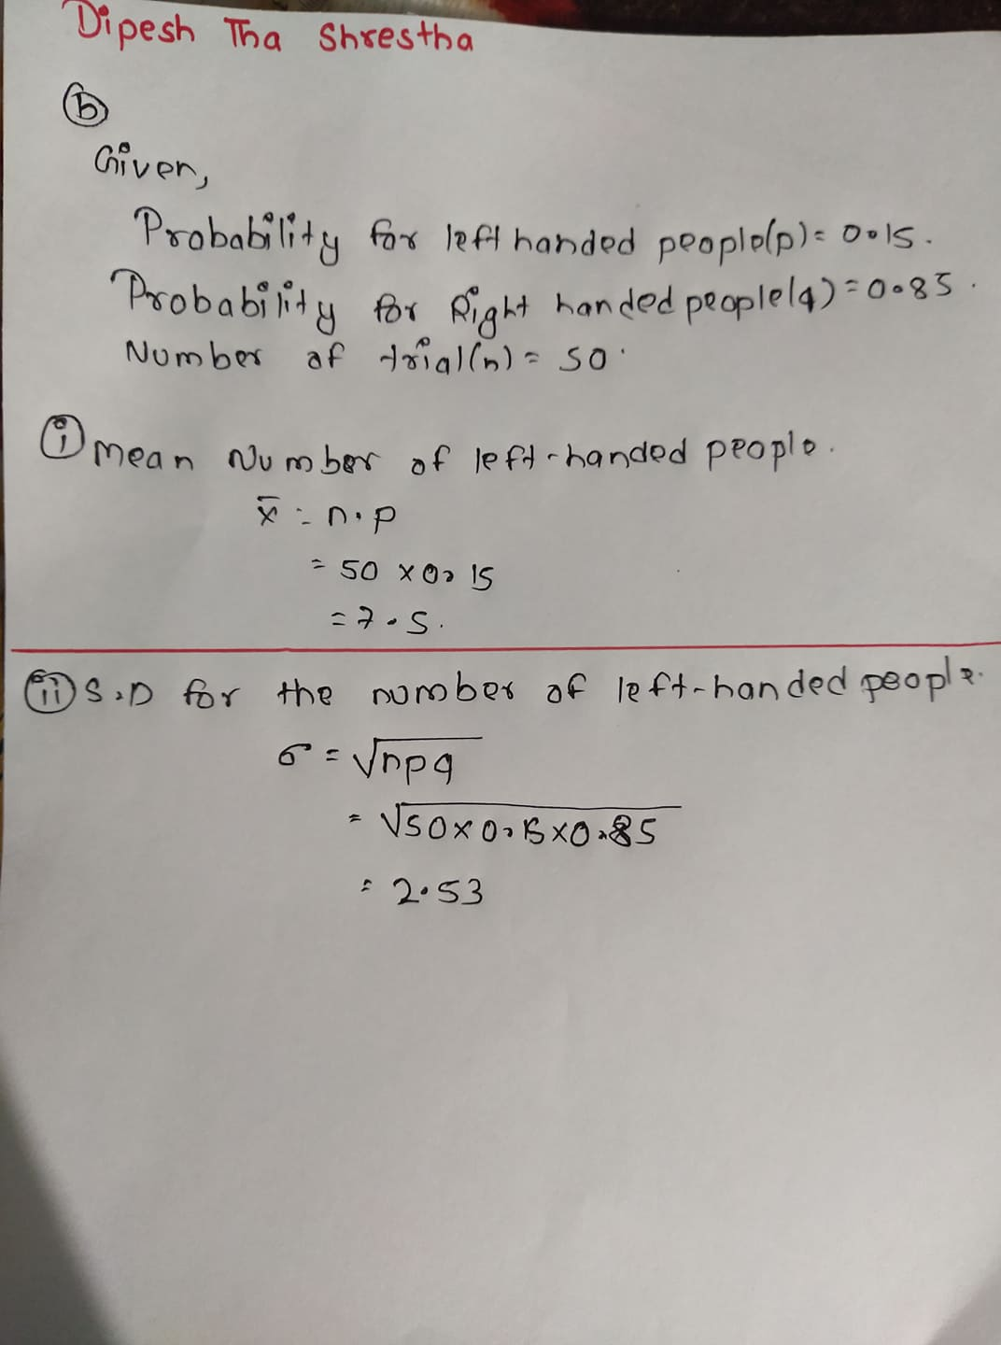

Q.N.6

The quality control manager of certain company is inspecting batch of chocolate chip cookies that have just been baked. If the production process is in control, the average number of chip parts per cookies is 6. What is the probability that in any particular cookies being inspected,

1. At most three chip parts will be found?
2. None of the chip parts will be found?

